New Hire Checklist for HR

| **Task** | **Done** | **Not applicable** | **Note** |
| --- | --- | --- | --- |
| **New hire paperwork checklist** | | | |
| Signed and documented offer letter and contract, outlining the terms and conditions of employment | ☐ | ☐ |  |
| Tax forms | ☐ | ☐ |  |
| Copies of identification documents (e.g., passport or driver’s license) | ☐ | ☐ |  |
| Emergency contact information | ☐ | ☐ |  |
| Benefits enrollment forms (including health insurance, pension, and other benefit plans) | ☐ | ☐ |  |
| Non-disclosure agreement (NDA) or confidentiality agreement | ☐ | ☐ |  |
| **Onboarding tasks** | | | |
| Input new hire’s information into the payroll system accurately | ☐ | ☐ |  |
| Create profiles in the necessary internal systems | ☐ | ☐ |  |
| Arrange office access cards or passwords | ☐ | ☐ |  |
| Set up all IT accounts (including email accounts, software installations, and access to shared drives) | ☐ | ☐ |  |
| Conduct health and safety training | ☐ | ☐ |  |
| **Welcome pack for new employee** | | | |
| A company overview that includes mission, vision, values, and organizational structure | ☐ | ☐ |  |
| An employee handbook outlining policies, procedures, and code of conduct | ☐ | ☐ |  |
| The first week’s schedule with a full orientation and introduction phase itinerary | ☐ | ☐ |  |
| A directory of relevant team members, departments, and their roles | ☐ | ☐ |  |

[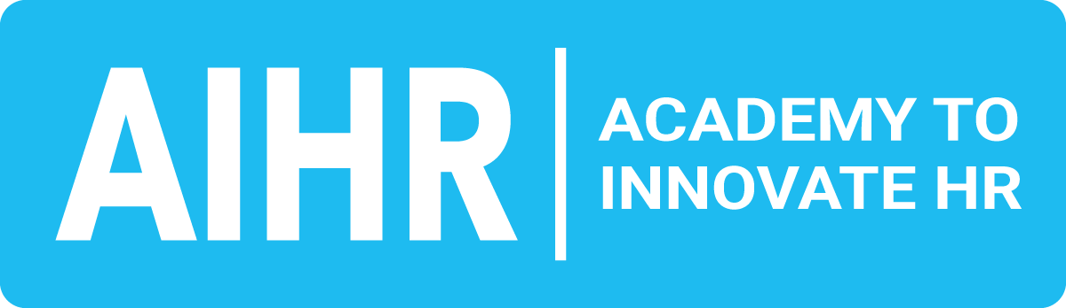](http://aihr.com)

[aihr.com](https://www.aihr.com/)

| Task | Done | Not applicable | Note |
| --- | --- | --- | --- |
| **Welcome announcement for new employee** | | | |
| Email or a notice on the intranet introducing the new hire, their role, and background | ☐ | ☐ |  |
| A scheduled meeting with direct teammates and supervisors, either in person or virtually | ☐ | ☐ |  |
| Add new employee to the organizational chart | ☐ | ☐ |  |
| **Mentorship or buddy system implementation** | | | |
| Pair a new employee with a seasoned team member to ease the transition, and to offer guidance, insights, and a friendly point of contact | ☐ | ☐ |  |
| **Continuous feedback and support** | | | |
| Schedule regular check-ins including HR and immediate supervisors during the first few months to provide continuous support and address any concerns | ☐ | ☐ |  |
| A formal review after the initial 90 days to assess progress, alignment with company goals, and set further development plans | ☐ | ☐ |  |
| **Cultural integration and social engagement** | | | |
| Provide insights into the company culture, traditions, and values through cultural onboarding sessions | ☐ | ☐ |  |
| Organize informal gatherings or team-building activities to facilitate social integration within the team | ☐ | ☐ |  |
| **Professional development and training plans** | | | |
| Depending on the role, lay out specific training or development courses that align with the job description and future growth within the organization | ☐ | ☐ |  |
| Offer access to online platforms or in-house training materials to encourage continuous learning | ☐ | ☐ |  |

[](http://aihr.com)

[aihr.com](https://www.aihr.com/)

| Task | Done | Not applicable | Note |
| --- | --- | --- | --- |
| **Accessibility and inclusivity measures** | | | |
| Ensure that any specific requirements related to disabilities are addressed | ☐ | ☐ |  |
| Provide training on diversity and inclusivity to create a respectful and supportive environment | ☐ | ☐ |  |
| **Exit strategy from the onboarding program** | | | |
| Create a planned transition from the onboarding program into full engagement with the team, marked by clear milestones and communicated expectations | ☐ | ☐ |  |
| Gather insights from the new hire on their experience with the onboarding process, for continuous improvement | ☐ | ☐ |  |

[](http://aihr.com)

[aihr.com](https://www.aihr.com/)

