Employee Satisfaction Survey

|  |
| --- |
| This is a survey for employees of [COMPANY NAME]. The aim is to understand the working conditions, professional expectations, and overall job satisfaction of all our team members.  Your feedback is anonymous. Filling in the survey should take you a maximum of 5-10 minutes.  Your responses will help us identify areas that need improvement and improve the working experience for everyone. |

|  |  |  |  |  |
| --- | --- | --- | --- | --- |
| How long have you been working at the company? | | | | |
| < 1 year | 1-2 years | 2-5 years | 6-10 years | 10+ years |
|  |  |  |  |  |

|  |  |  |  |  |  |  |
| --- | --- | --- | --- | --- | --- | --- |
| **Please rate your satisfaction with the following aspects of your experience as an employee at our company.** | | | | | | |
| **Scale** | Extremely dissatisfied | Dissatisfied | Neutral | Satisfied | Extremely satisfied | Not applicable |
| Your job overall |  |  |  |  |  |  |
| Having your work recognized and appreciated |  |  |  |  |  |  |
| Communication from management |  |  |  |  |  |  |
| Access to the tools and resources to perform your job effectively |  |  |  |  |  |  |
| Opportunities to provide feedback to your supervisor |  |  |  |  |  |  |
| Opportunities for professional growth in our company |  |  |  |  |  |  |
| Work-life balance |  |  |  |  |  |  |
| Compensation & benefits |  |  |  |  |  |  |

|  |  |  |  |  |  |  |  |  |  |  |
| --- | --- | --- | --- | --- | --- | --- | --- | --- | --- | --- |
| How likely are you to recommend our company to a friend as a good place to work?  (1 = Extremely unlikely, 10 = Extremely likely) | 1 | 2 | 3 | 4 | 5 | 6 | 7 | 8 | 9 | 10 |
|  |  |  |  |  |  |  |  |  |  |

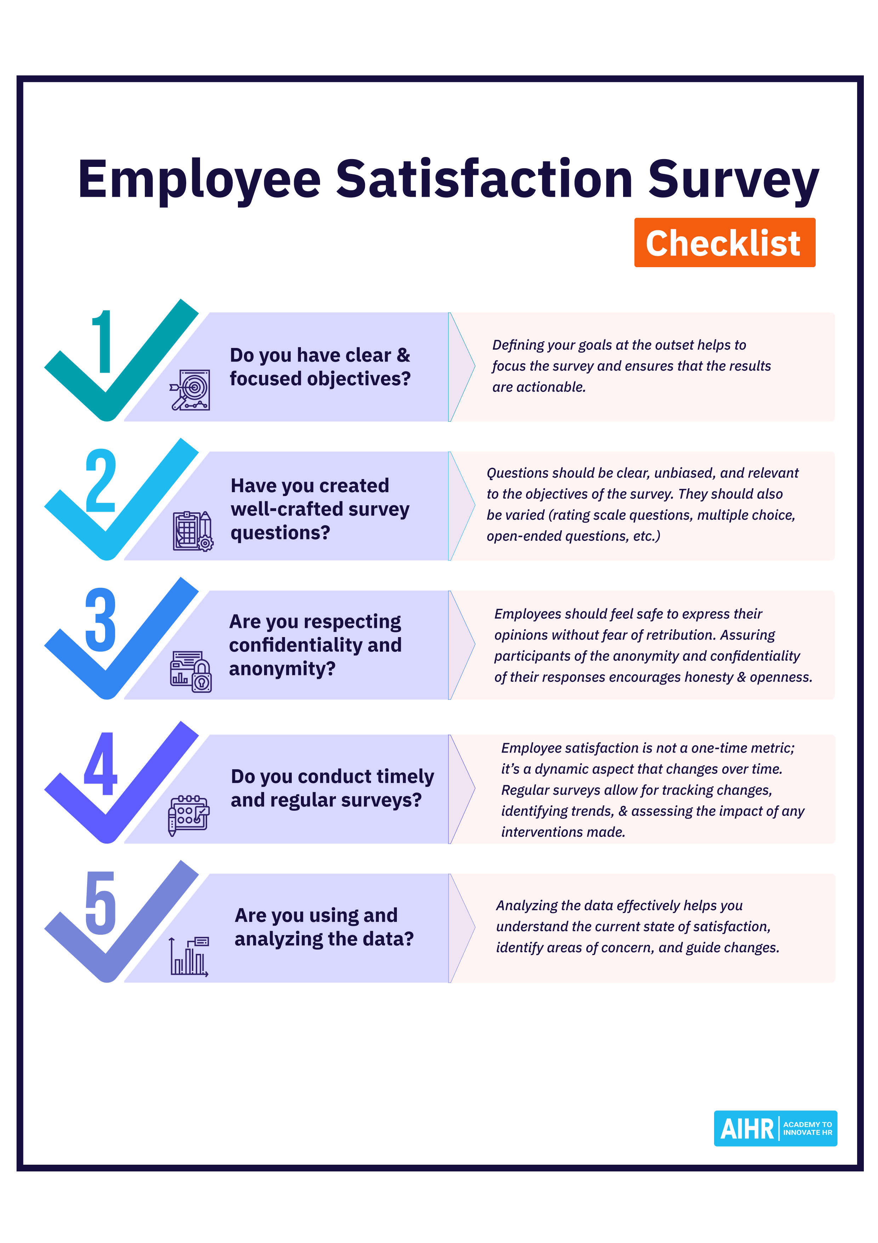

[aihr.com](https://www.aihr.com/)

[](https://www.aihr.com/platform/?utm_source=resource&utm_medium=resource&utm_campaign=templates&utm_content=templates)